# What the Process is?

Process is mechanism to structure the diverse set of activities that are involved in building software systems. There are diverse set of processes available for structuring the development of software products. And these can be separated into 2 major categories. So, the Traditional category includes things like waterfall and spiral. More modern category includes processes like XP, TDD, and Scrum. Talking about process, there is no TRUE process. Each team choose process based on their needs and own constraints.

# Traditional approaches

## Waterfall

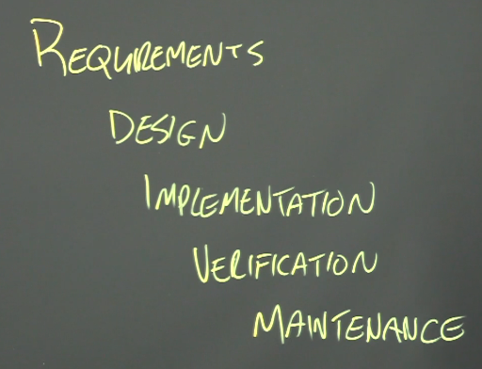

Classic

Go from one step to the next to the next

No stepping back

Make sure each step is finished

No confidence that the system is useful. Not responsive to user needs.

Extremely resistant to changes

Distinct -> easy to know what is happening at this moment

Clear. Each phase has a concrete document that should be followed -> resistance to change

## Spiral

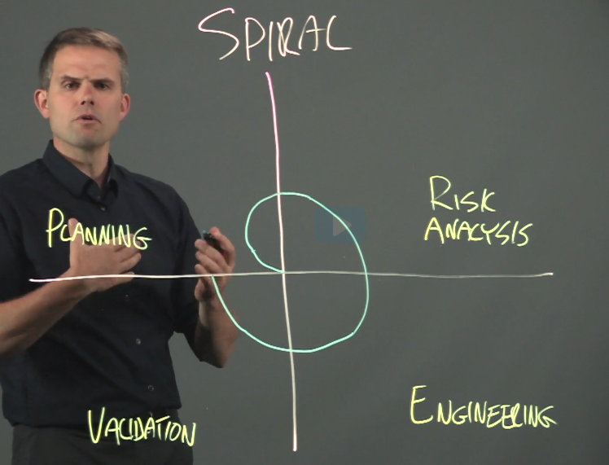

About a year for iteration

Collect users’ responses

Waiting response for a year is slows down

# Agile

Response to traditional approaches

Tightening the loop between developers and users

## XP

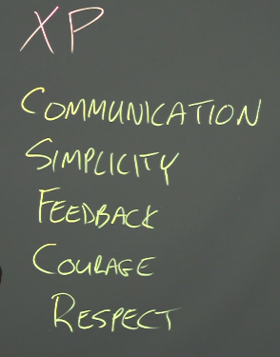

## TDD

Not only buildable, but also works within constraints at any given time

Write tests first

Forcing programmers to write tests in advance -> testable manner of code -> great habit

Testing before writing is difficult ugh

## Scrum

Product backlog: issues and bugs to be fixed

Series of sprints (1-3 weeks long)

Sprint backlog is subset of product backlog

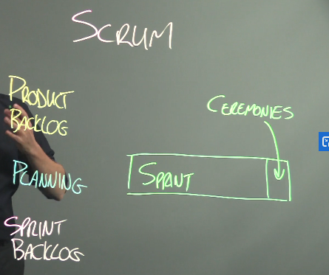

Stand-up meeting

Goes over the process

What’s blocking

Working on last

Working on next

10 -15 minutes status update

Ceremony is demo and feedback time